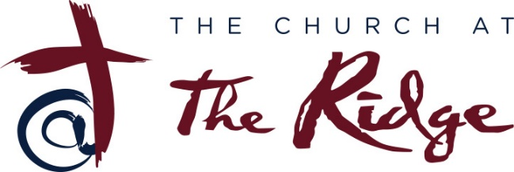
Part Time Administrative Assistant
Role Definition: Provides overall ministry support to the pastoral staff and elders (as needed). Serves as financial liaison to the Offsite Bookkeeper.
Purpose: To create an inviting and gracious atmosphere for visitors to the church and office and to assist the Pastor(s) with general office tasks and systems that help the church operate effectively, efficiently, and creatively. Help with communication systems to the church body.
Schedule: 15 – 16 hours/Likely 2 – 3 days per week (flexible days).
Compensation: Part-time without fringe benefits.
Admin Assistant Responsibilities:
- Supportive and enthusiastic, with the ability to articulate the vision and values of The Ridge to any caller or guest.
- Receive and direct guests that come into the office for both scheduled appointments and walk- ins.
  - Gatekeeper for the Pastor(s).
- Manage mail and package deliveries.
- Maintain Church’s Website.
- Social Media savvy. Able to maintain and utilize various social media (Facebook, Instagram, and YouTube) for communication to the church body and community. Also be able to email and text information to our Church Members and Church leaders on a regular basis.
- Help coordinate volunteers of the Church with Church Events.
- Maintain the Church’s Calendar of Events.
- Send out Quarterly Statements of Church Members’ Giving Statements.
- Scanning and sending invoices, purchase orders, check requests, etc. to the offsite bookkeeper.
- Phone Answering:
  - Be knowledgeable about church events to be able to answer questions (who, what, when, where, and how).
- Maintain office supplies.
- Assist ministry team leaders (i.e., small groups, RidgeKids, and students) with ordering curriculum.
- Process/manage facility and bus use requests.
- Manage key sign out system.
- Assist/manage data entry and records in database systems. Be able to work with the Church’s online database system Tithe.ly.
- Manage reception area and Community Room.
- Communicate with Elders, Volunteer Coordinators and Ministry Team leaders on behalf of Pastor(s) as needed.
- Other related duties as needed.
Requirements:
- Computer Skills (Excel, Word, Publisher, Adobe, etc.)
- Database Skills
- Consistent, growing Christian walk
- Willing to be a member at The Ridge is preferred, but not required
- Personable and caring
- Flexible
- Dependable
- Organized
- Diligent
- Self-starter
- Strong Integrity
- Able to keep confidence
- Professional attitude

